# CREATE A CHATBOT IN PYTHON

PHASE-3

Introduction

In this document, we will walk through the process of building a chatbot using Flask, an open-source web framework for Python. The chatbot will utilize a pre-processed dataset, installing libraries, integrating ( OpenAI's GPT-3) and Flask web app.

Prerequisites

* Basic understanding of Python programming language.
* Familiarity with web development concepts and Flask framework.
* Access to OpenAI API key for using the GPT-2 model.
* Python environment with necessary libraries installed.

steps

**1. Preprocessing the Dataset**

* Loading the Dataset
* Load the dataset from a file (e.g., **dialogs.txt**) using a pandas , DataFrame. Each line in the
* file should contain a user input and a corresponding response, separated by a delimiter (e.g., tab **\t**).

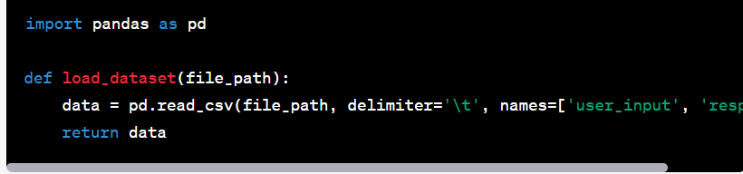

Cleaning the Text

Implement a function to clean the text data. Common cleaning steps include converting text to lowercase, removing special characters, digits, and extra whitespace.

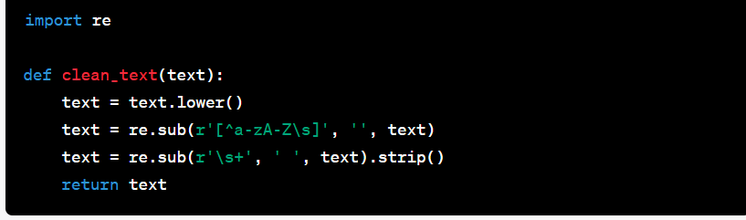

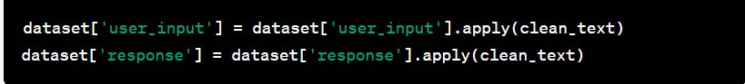Apply the cleaning function to the dataset.

2. Building the Chatbot

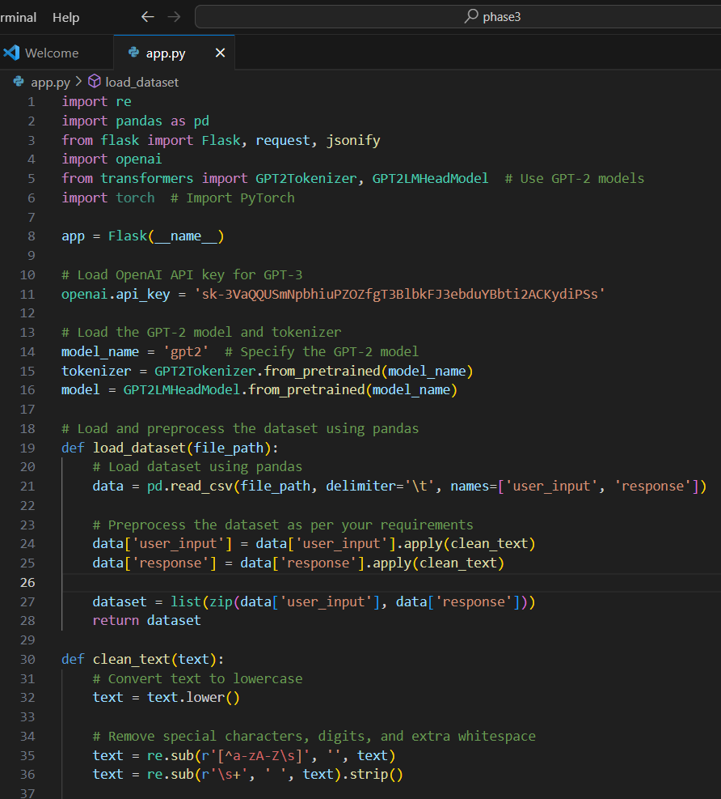Create a Flask web application and implement a route to handle incoming chat requests.

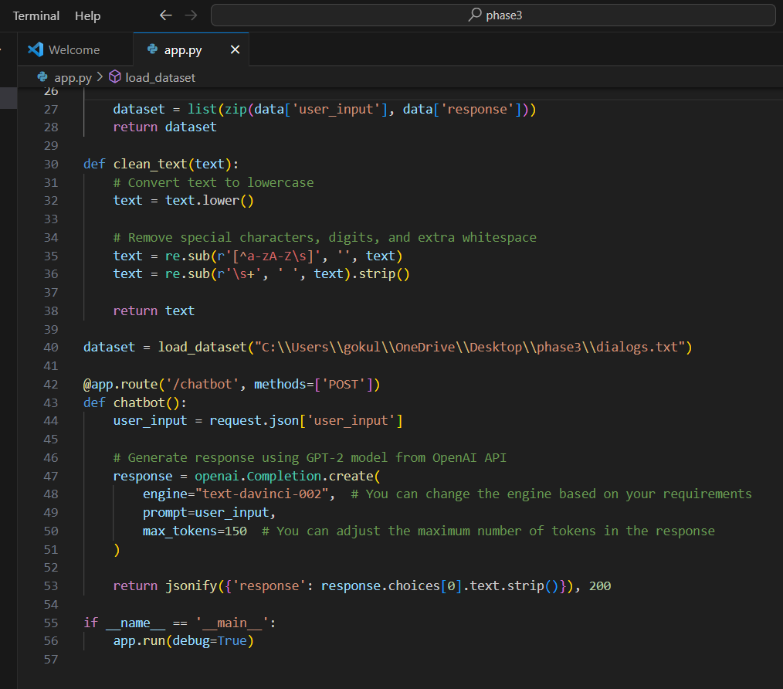

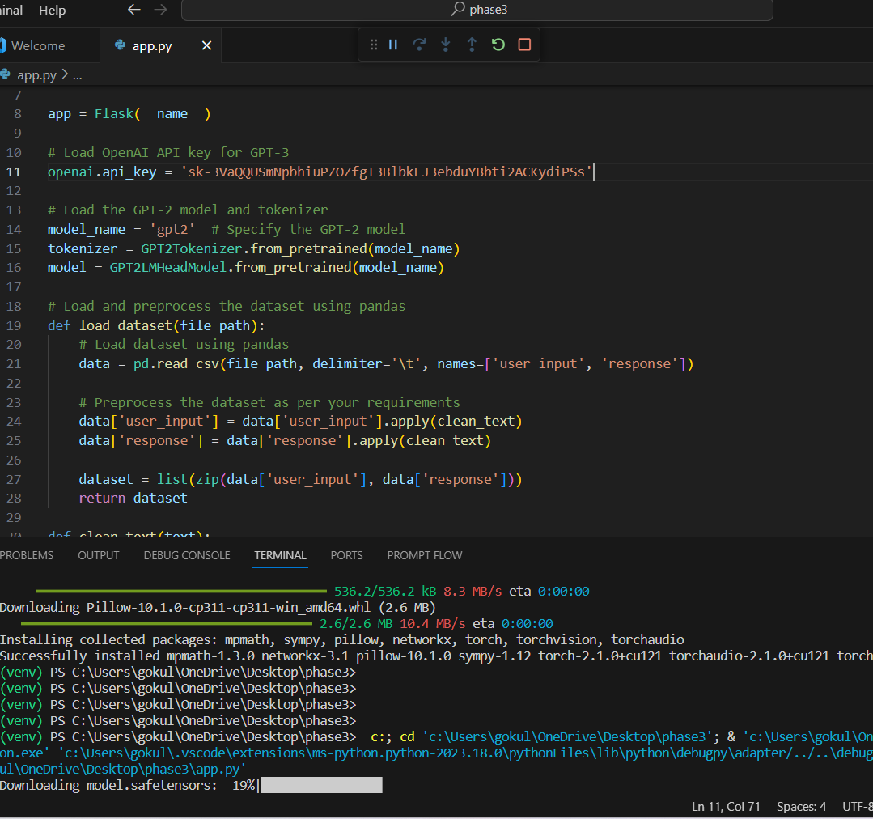

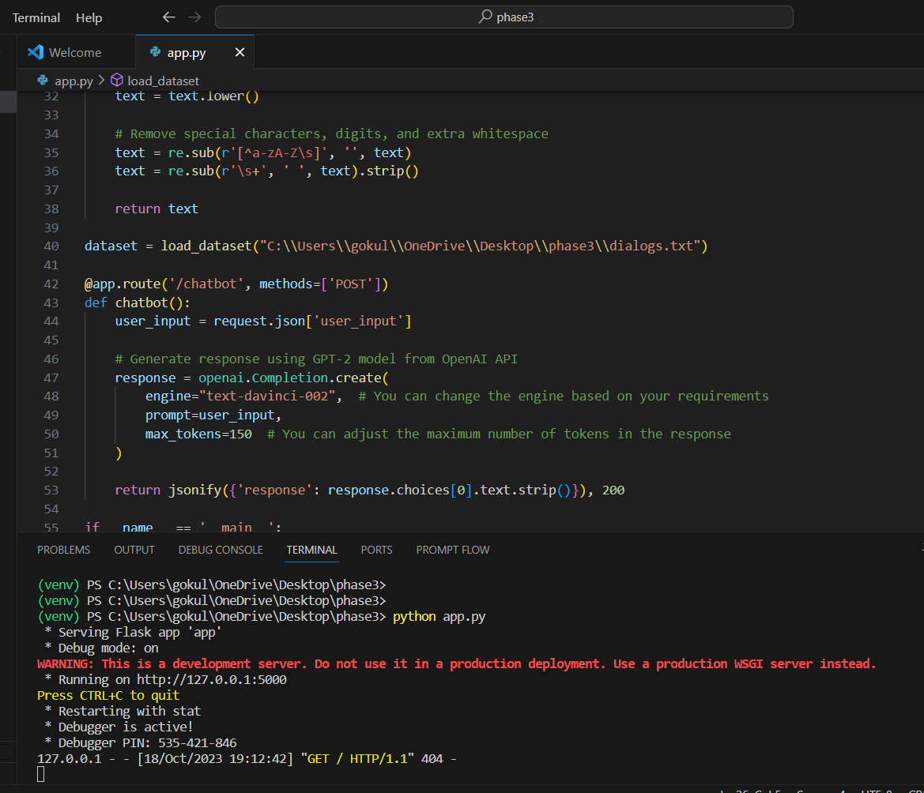

**3. Deploying the Flask Web App**

Run the Flask application. Ensure your API key, models, and dependencies are properly configured.



The Flask app will be hosted locally, and you can interact with the chatbot endpoint (/chatbot) using HTTP POST requests.

Conclusion

By following these steps, you have built a chatbot web application using Flask, pre-processed a dataset, and integrated the OpenAI GPT-3model for generating responses. You can further enhance the chatbot by refining the preprocessing steps, exploring different language models, and adding more features to the Flask application.